Institute Of Fine Arts

**PROJECT GROUP MEMBERS**

|  |  |
| --- | --- |
| **Students Id** | **Students Name** |
| *Student1434943* | *Muhammad Mohtashim* |
| *Student1430194* | Hafiz Abdur Rafay |
| *Student1435114* | *Syed Muhammad Ibad* |
| *Student1435107* | *Shuja Abbas* |
| *Student1452991* | *Muhammad Azam* |
| *Student1431524* | Ameer Hamza |

**CURRICULUM**

**7062**

**BATCH**

**2302B1**

**SEMESTER**

**3RD**

**CO-ORDINATOR**

**MISS MAHA HAIDER**

**FACULTY**

**SIR HARIS NASEER**

**Certificate**

This is to certify that the dissertation **“Institute Of Fine Arts”** is **Muhammad Mohtashim Student 1434943, Hafiz Abdul Rafay Student 1450194, Syed Muhammad Ibad Student 1435114 Shuja Abbas Student 1435107 Muhammad Azam Student 1452991 Ameer Hamza Student 1431524** in their partial fulfilment of the requirement of the award of the Aptech Computer Certified.

**Acknowledgement**

The success and final outcome of this project required a lot of guidance and assistance from many people and I am extremely privileged to have got this all along the completion of my project. All that I have done is only due to such supervision and assistance and I would not forget to thank them.

I respect and thank Aptech for providing me an opportunity to do the project work in ACE and giving us all support and guidance, which made me complete the project duly. I am extremely thankful to Aptech for providing such a nice support and guidance.

I owe my deep gratitude to our project guide **SIR HARIS NASEER**, who took keen interest on our project work and guided us all along, till the completion of our project work by providing all the necessary information for developing a good system.

**INTRODUCTION**

Our client is an institute by the name “Institute of Fine Arts”, which has been started by the two well-trained professionals who are one of the standard people in the field of animation and fine arts. The procedures that they follow are they first conduct classes on paintings, animation, etc.

During the course schedules, they conduct competitions among the students, for which all the students must participate in these competitions and have to submit their paintings with in the stipulated time. They ask the students to come up with some paintings, which they need to create with their own creativity along with some sentences like poems, quotations, stories, etc. that are to be described along with their paintings. The students based on their creativity, design on their respective computers and then submit their designs (paintings) in the form of a jpeg file, with in the stipulated time to the college.

Once the due date is crossed, the submissions of the designs as created by the students will not be accepted. These students will be disqualified in the competitions. And after the due date the college will not evaluate the designs received from the students based on the creativity and the quotations or poems, and then they will select the best designs and distribute the awards to the students with the best designs.

They at times in order to boost up the competitive spirit in the students, they will display the best paintings done by the students in the exhibitions, at which the paintings will be sold at the price decided by the painter (Student). The money received for the painting which is sold out in the exhibition is handed over to the student itself.

***Existing Scenario:*** *–*

They usually maintain the competition details through pen and paper. Because of which they are facing the problems in retrieving and fetching the records, for which it consumes too much of time, as when a student wants to change the painting submitted, etc. the staff should first search the records and then update the details accordingly.

***Proposed Solution:*** –

Now, the management had come up with a new idea where in they can have a website of their own. In this website they want to implement these competitions, where in they can announce the competitions, provide a facility for the students to upload and download the image files. Also the student can update or remove the pictures of the same. Thus through this website they can automate the process, and as well reduce the time consumption in evaluating and fetching the records of the students, designs, etc. So they had approached you to help them by building a website by building the following functionalities, in it.

**►Non-Financial:**

The website which you build must have the following functionalities.

1. The website should have the following modules
   * Manager
   * Administrator
   * Staff (teacher)
   * Student
2. On the home page, the details of the upcoming competitions, ongoing competitions, the list of the students who are awarded for the previous competition, the total submissions done for the ongoing competition, etc.
3. Through the administrator module, one can perform the following functionalities
   * Maintain (insert, update, delete and search and retrieve) the details of the staff along with the login details, personal details, work details (like when joined this institution, handles which class, handles which subject, etc.), remarks.
   * Maintain (insert, update, delete and search and retrieve) the details of the students along with the login details, personal, admission details.
4. Through the staff login one should be able to perform the following.
   * View the details of the students (personal, and admission details)
   * Maintain (insert, update, delete and search and retrieve) the details of the competitions along with the start date, end date, conditions, award details (like what are the awards that are to be issued for that competition), etc.
   * Maintain (insert, update, delete and search and retrieve) the details of the student’s academic records like they can view the postings done (like the designs as posted by the students, details of the quotations, stories, poems, etc. submitted along with the designs, the date on which it is posted, for which competition is posted), and then they can mark it as either best, or better, or good, or moderate, or normal (based on the creativity and the quotations or poems submitted), or as disqualified (if the date submitted is beyond the end date for the competition) and describe the remarks, like the positive points about the design, negative points about the design, and that of the areas of improvement.
   * Maintain (insert, update, delete and search and retrieve) the details of the awards issued, like which student is awarded and for which competition did the student is awarded, remarks of the competition.
   * Maintain (insert, update, delete and search and retrieve) the details of the upcoming exhibitions that are to be conducted with in the country, so that the students can view the details of the upcoming exhibitions and forward their (students) paintings to the exhibition.
   * Maintain (search and retrieve) the details of the students designs submitted based on the mark assigned (like best, better, good, moderate, normal and disqualified), so that they (staff) can forward the best paintings to the exhibitions for the price that the student has quoted.
   * Maintain (insert, update, delete and search and retrieve) the list of the designs that are sent to the exhibition, along with the price, and the status (like whether the painting is sold out or not, if sold out, what is the price at which it is sold out, whether the money paid for the painting at the time of sale is returned or paid to the student or not), the details of the customer who purchased the painting if the painting is sold, etc.
5. Through the student login one should be able to perform the following.
   * The student should be able to view the upcoming competition details along with the awards, details, conditions, etc.
   * The student must be able to upload the designs or the paintings created along with the quotations, stories, etc.
   * The student must be able to change the design or the painting, or the quotations or the story or the description for the painting (why did the student created or designed this painting, why should this painting be the best, etc.) or the poem, etc. once is it is uploaded on the site, provided the end date for the competition in which he/she has submitted this design is not exceeded.
   * Should be able to view the awards given based on the on the competition conducted.
   * Should be able to view all the postings that are marked as best, along with the comments from the staff (areas of improvement, etc.)
   * Should be able to view all the postings that are sent for the exhibitions along with the status (like price of the painting, whether the painting is sold or not, whether the student is paid or not, how much is paid by the customer for that painting sold, etc.)
   * Should be able to view the marks (best, better, etc.) and remarks (like areas of improvement, positive points, etc.) as posted or provided by the staff, for all the paintings that are posted along with the poems, quotations, etc. based on the competitions conducted and he/she had participated till now.
6. Through the Manager login one should be able to maintain the following.
   * Should be able to view the details of the students and staff details
   * Should be able to view the competition details that are held till now.
   * Should be able to view the details of the awards issued.
   * Should be able to view all the postings done by all the students till now based on the competitions that are conducted till now.
   * Should be able to view the marks or remarks as provided by the staff for a particular painting.
   * Should be able to view the list of the paintings that are exhibited by the staff, along with the details.
   * Should be able to maintain the details of the upcoming exhibitions in the country

**►Financial:**

The details of the awards that are to be distributed, price levied on the painting before exhibiting, the sold out price, are to be maintained.

***Functional Requirements: –***

1. The database should hold the details of the students, staffs (manager, administrator and the staff (lecturers) of the institute), competitions, awards, postings (of the paintings, date of posting, descriptions of the paintings, quotations, etc. as provided by the student, marks, remarks for the painting as provided by the staff), exhibition details, details of the awards issued, postings send to the exhibition along with the status, etc.
2. You must design an interface, through which the following are to be implemented
   * Students can upload or edit or delete and search and retrieve the paintings that are posted based on the eligibility.
   * Staffs can view the postings posted along with the details, and mark it as the best or better, etc. and provide the remarks.
3. The reports are to be generated like the submissions received over a particular period for a particular competition that are best, etc.

Note: for uploading, editing, downloading the images or the painting you must use File I/O.

**OBJECTIVE**

The Objective of this program is to give a sample project to work on real life

projects. These applications help you build a larger more robust application.

The objective is not to teach you the software’s but to provide you with a real life

scenario and help you create basic applications using the tools.

You can revise the topics before you start with the project.

These programs should be done in the Lab sessions with assistance of the faculty if

required.

It is very essential that a student has a clear understanding of the subject.

Kindly get back to eProjects Team in case of any doubts regarding the application or

its objectives.**REQUIREMENTS SPECIFICATION**

# Hardware/ Software Requirements

**Hardware**

**1. A minimum computer system that will help you access all the tools in the**

**courses is a Pentium 166 or better**

**2. 64 Megabytes of RAM or better**

**3. Windows 98 (or higher if possible)**

**4. Java Virtual Machine**

**Software**

**Either or combination of the following Software’s are to be used:**

**▪ Notepad/HTML editor/Java editor**

**▪ Dream weaver/JavaScript**

**▪ j2sdk1.4.1_02 (or later) / .Net / J2EE**

**▪ JSP / Servlets**

**▪ EJB / Struts**

**▪ JDBC**

**▪ SQL Server 2000 (or later) / Oracle 9i / MS Access**

**▪ JDBC Driver**

**DIAGRAM**

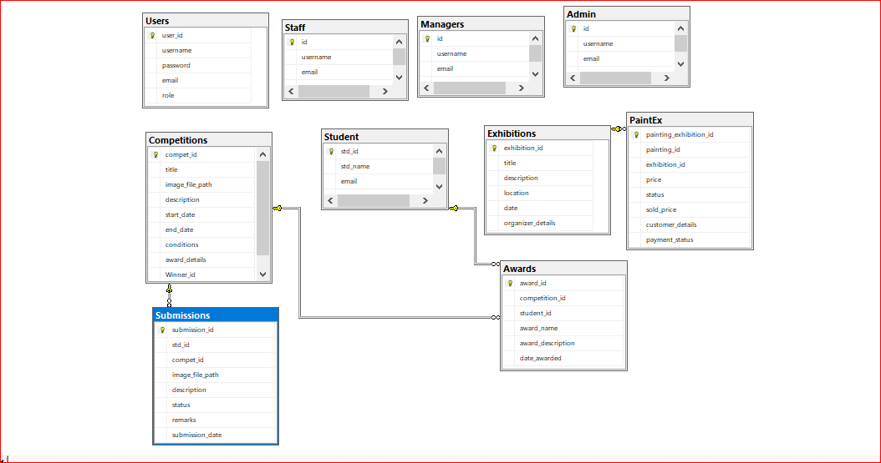

**ADMIN SCREENSHORTS**

**LOGIN**

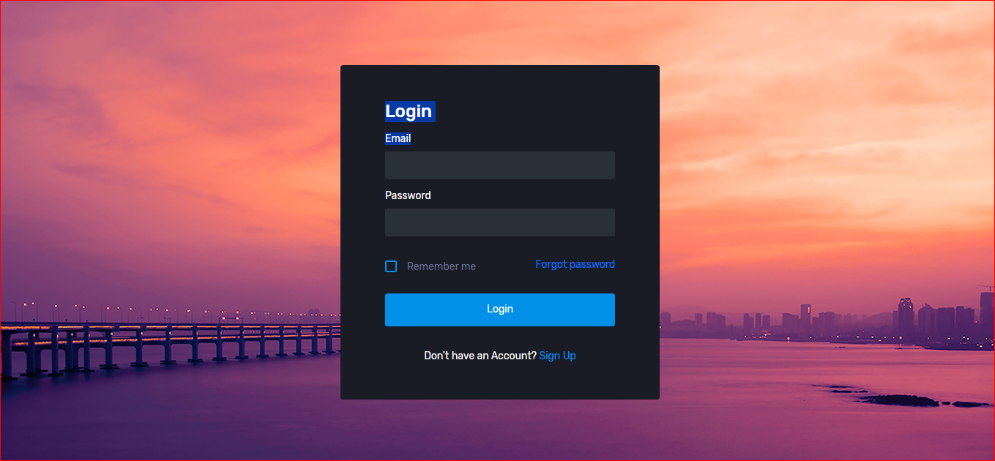

**SIGN UP**

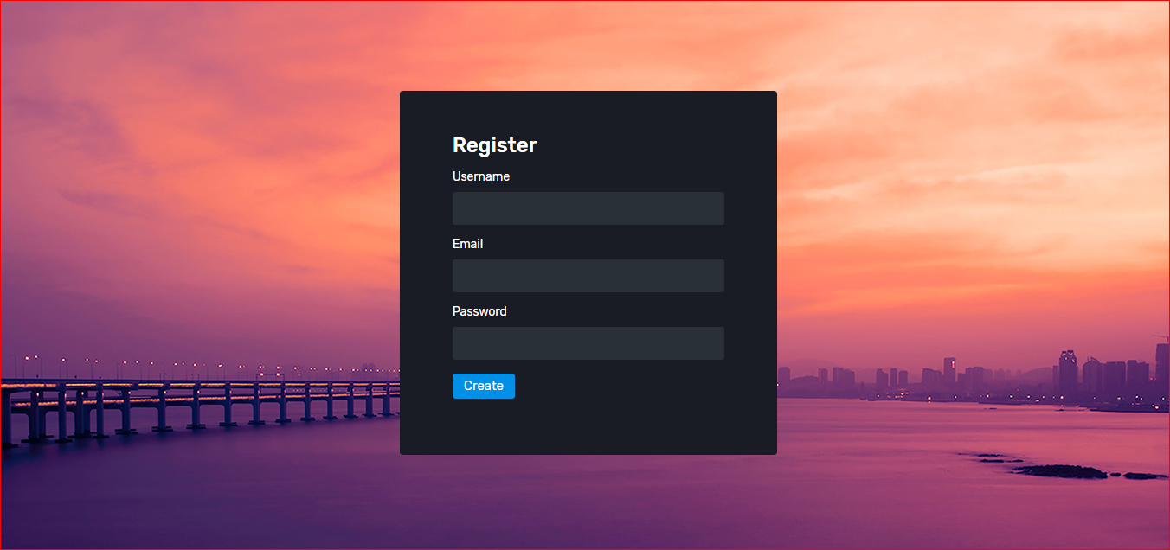

**ADD MANAGER**

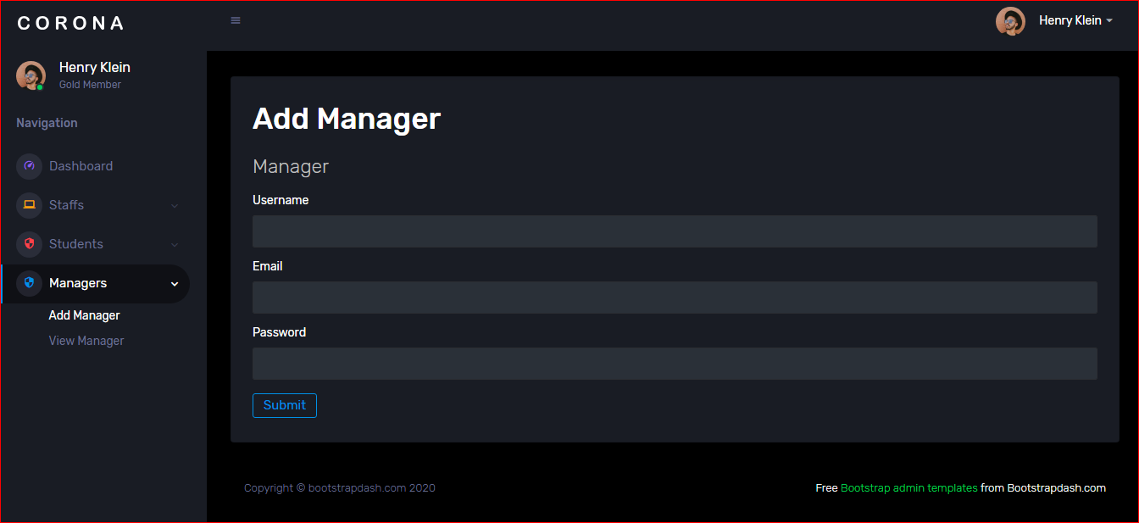

**ADD STAFF**

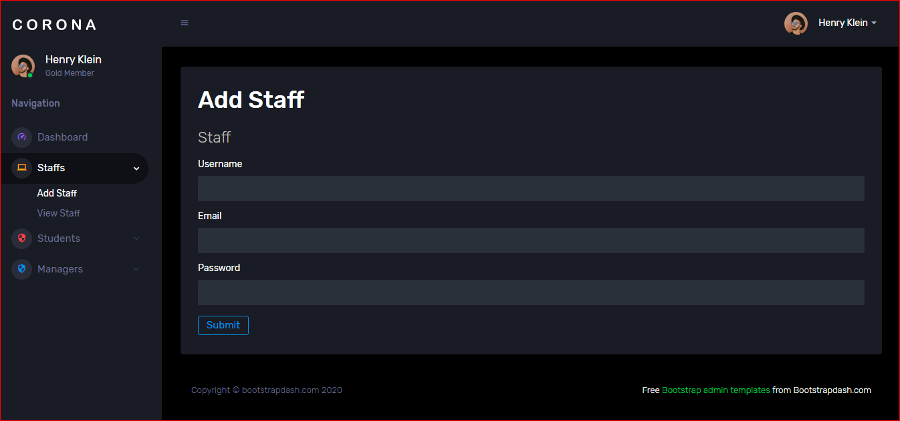

**ADD STUDENT**

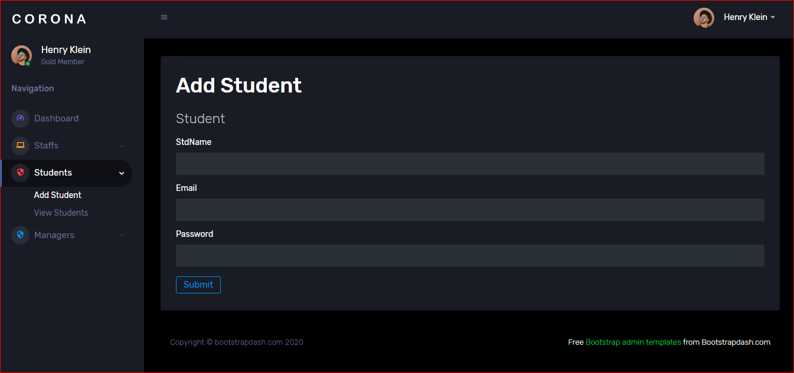

**ADD COMPETITION**

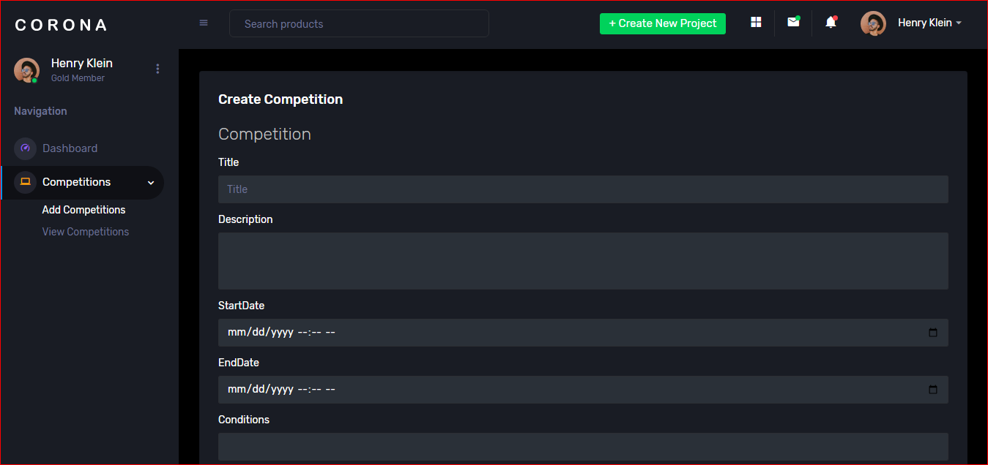

**VIEW COMPETION**

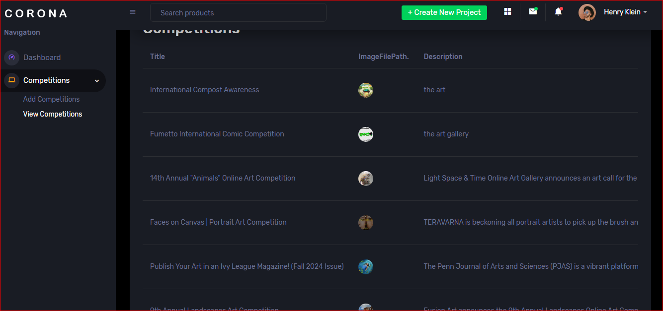

**VIEW STAFF**

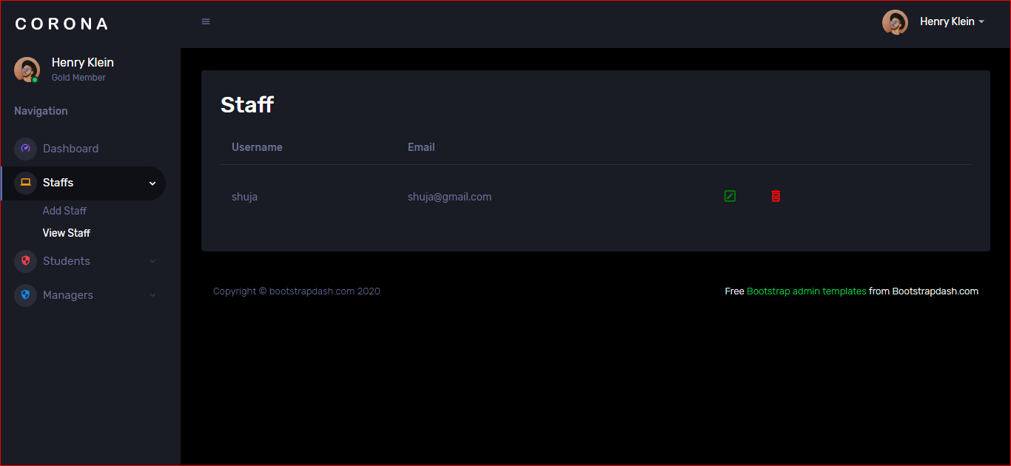

**VIEW MANAGER**

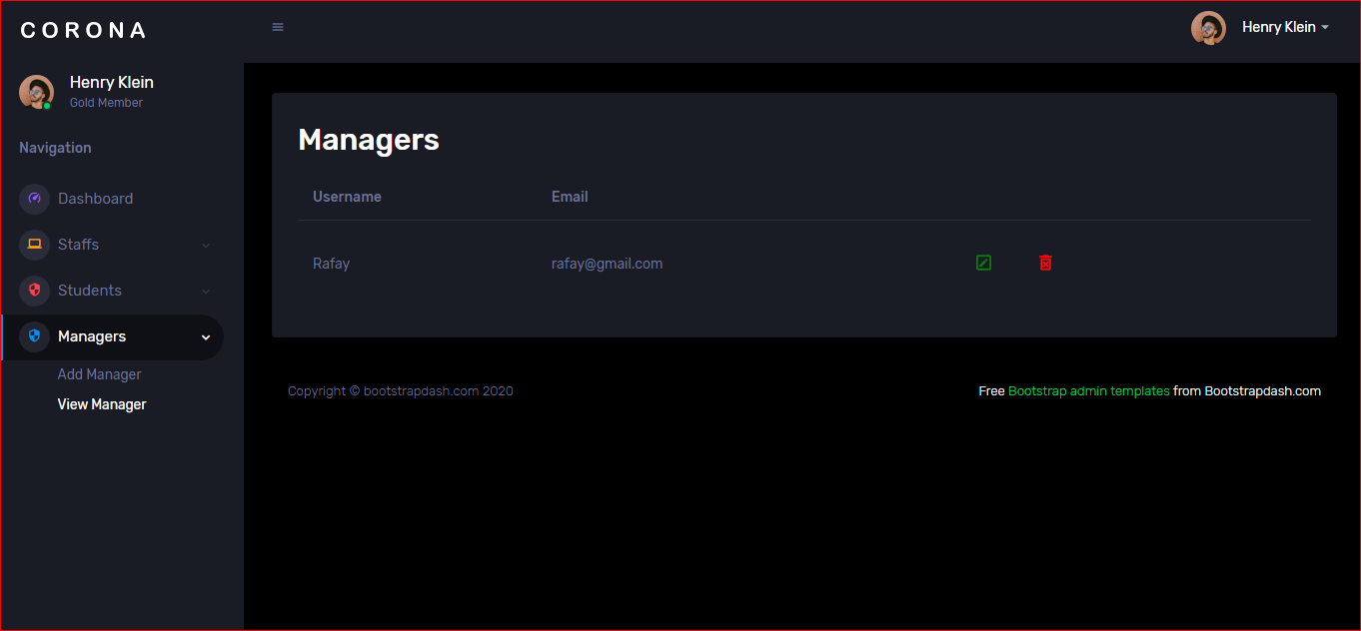

**HOME**



**ABOUT**



**CONTACT**

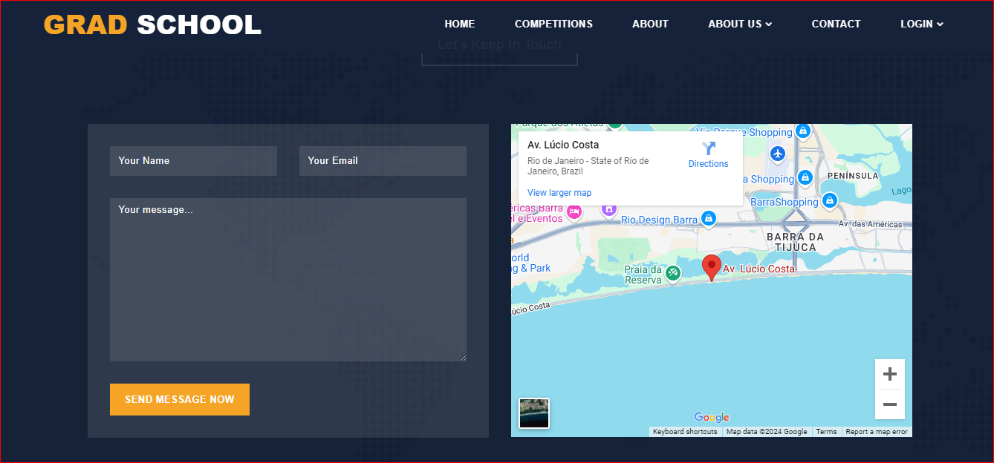

**LATEST COMPETITION**

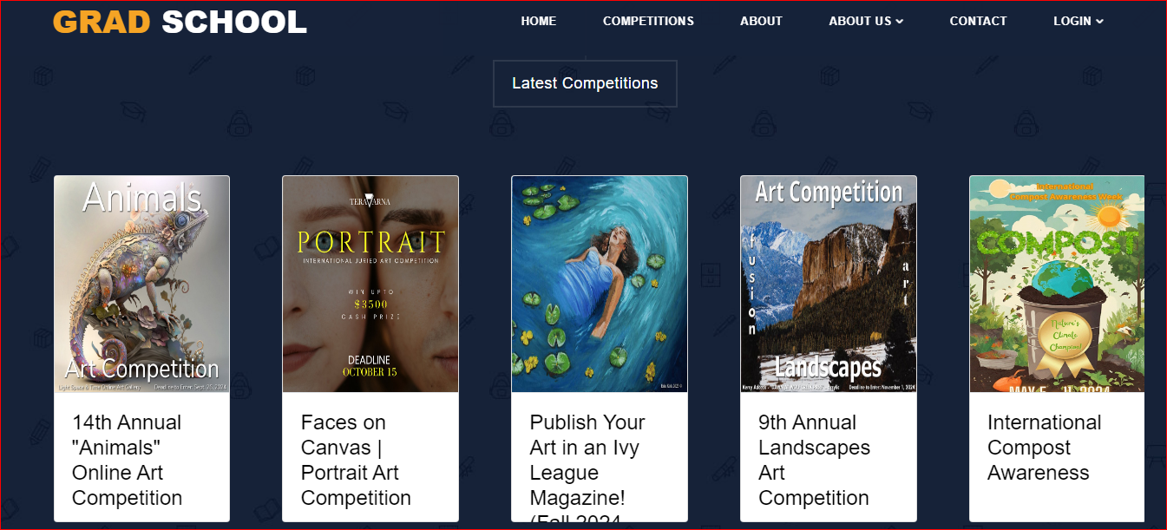

**TASKSHEET**

|  |  |  |  |
| --- | --- | --- | --- |
| ***sn*** | ***Task*** | ***Team-member*** | ***status*** |
| *1* | *Analysis* | *Shuja, Mohtashim, Rafay,Ibad* | *done* |
| *2* | *design* | *Shuja, Mohtashim, Rafay,Ibad* | *done* |
| *3* | *Development* | *Mohtashim, Rafay,Shuja,Ibad* | *done* |
| *4* | *Documentation* | *Shuja* | *done* |
| *5* | *finalization* | *Shuja, Mohtashim, Rafay,Ibad* | *done* |

**CHECK LIST**

|  |  |  |  |
| --- | --- | --- | --- |
| *S.no* | *List of items* | *Remarks* | *Comments* |
| ***1.*** | *Do All Pages Linked*  *together* | ***Yes*** | *✓* |
| ***2.*** | *Authorization* | ***Yes*** | *✓* |
| ***3.*** | *Crud Operations* | ***Yes*** | *✓* |
| ***4.*** | *Database Connection* | ***Yes*** | *✓* |
| ***5.*** | *Project Zip File* | ***Yes*** | *✓* |